**WEEK – 4(HandsOn)**

**Spring REST using Spring Boot 3**

1. **spring-rest-handson**

**1.Create a Spring Web Project using Maven :**

package com.cognizant;

import org.slf4j.Logger;

import org.slf4j.LoggerFactory;

import org.springframework.boot.SpringApplication;

import org.springframework.boot.autoconfigure.SpringBootApplication;

@SpringBootApplication

public class SpringLearnApplication {

private static final Logger LOGGER = LoggerFactory.getLogger(SpringLearnApplication.class);

public static void main(String[] args) {

SpringApplication.run(SpringLearnApplication.class, args);

LOGGER.info("Inside main");

}

}

<?xml version="1.0" encoding="UTF-8"?>

<project xmlns="http://maven.apache.org/POM/4.0.0" xmlns:xsi="http://www.w3.org/2001/XMLSchema-instance"

xsi:schemaLocation="http://maven.apache.org/POM/4.0.0 https://maven.apache.org/xsd/maven-4.0.0.xsd">

<modelVersion>4.0.0</modelVersion>

<parent>

<groupId>org.springframework.boot</groupId>

<artifactId>spring-boot-starter-parent</artifactId>

<version>3.5.3</version>

<relativePath/> <!-- lookup parent from repository -->

</parent>

<groupId>com.cognizant</groupId>

<artifactId>spring-learn</artifactId>

<version>0.0.1-SNAPSHOT</version>

<name>spring-learn</name>

<description>Demo project for Spring Boot</description>

<url/>

<licenses>

<license/>

</licenses>

<developers>

<developer/>

</developers>

<scm>

<connection/>

<developerConnection/>

<tag/>

<url/>

</scm>

<properties>

<java.version>17</java.version>

</properties>

<dependencies>

<dependency>

<groupId>org.springframework.boot</groupId>

<artifactId>spring-boot-starter-web</artifactId>

</dependency>

<dependency>

<groupId>org.springframework.boot</groupId>

<artifactId>spring-boot-devtools</artifactId>

<scope>runtime</scope>

<optional>true</optional>

</dependency>

<dependency>

<groupId>org.springframework.boot</groupId>

<artifactId>spring-boot-starter-test</artifactId>

<scope>test</scope>

</dependency>

</dependencies>

<build>

<plugins>

<plugin>

<groupId>org.springframework.boot</groupId>

<artifactId>spring-boot-maven-plugin</artifactId>

</plugin>

</plugins>

</build>

</project>

**OUTPUT:**

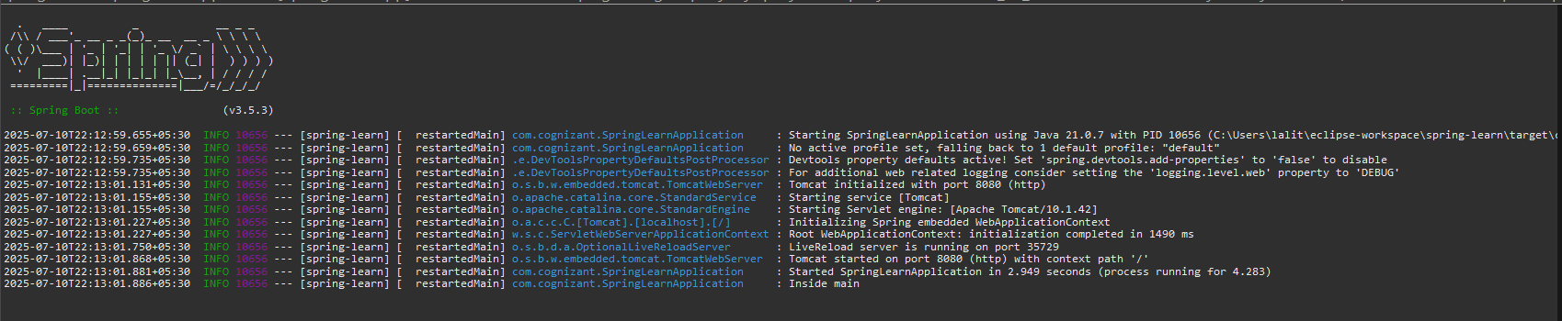

**2. Spring Core – Load SimpleDateFormat from Spring Configuration XML** .

<?xml version="1.0" encoding="UTF-8"?>

<beans xmlns="http://www.springframework.org/schema/beans"

xmlns:xsi="http://www.w3.org/2001/XMLSchema-instance"

xsi:schemaLocation="http://www.springframework.org/schema/beans

https://www.springframework.org/schema/beans/spring-beans.xsd">

<bean id="dateFormat" class="java.text.SimpleDateFormat">

<constructor-arg value="dd/MM/yyyy" />

</bean>

</beans>

package com.cognizant;

import java.text.ParseException;

import java.text.SimpleDateFormat;

import java.util.Date;

import org.slf4j.Logger;

import org.slf4j.LoggerFactory;

import org.springframework.boot.SpringApplication;

import org.springframework.boot.autoconfigure.SpringBootApplication;

import org.springframework.context.ApplicationContext;

import org.springframework.context.support.ClassPathXmlApplicationContext;

@SpringBootApplication

public class SpringLearnApplication {

private static final Logger LOGGER = LoggerFactory.getLogger(SpringLearnApplication.class);

public static void main(String[] args) {

SpringApplication.run(SpringLearnApplication.class, args);

LOGGER.info("Inside main");

displayDate();

}

public static void displayDate() {

ApplicationContext context = new ClassPathXmlApplicationContext("date-format.xml");

SimpleDateFormat format = context.getBean("dateFormat", SimpleDateFormat.class);

try {

Date date = format.parse("31/12/2018");

System.out.println(date);

} catch (ParseException e) {

e.printStackTrace();

}

}

}

**OUTPUT:**

